Task on Jenkins - 02

1) Configure 2 slave machines in jenkins master.

Launch 2 instances Salve – 01 and salve - 02. (Ubuntu 24.04 LTS)

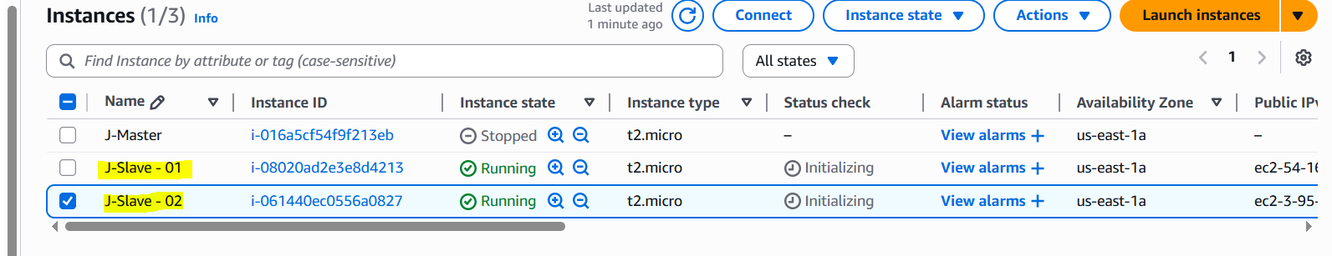

Steps to be done on slave
======================
Login to slave machine..
switch to root user
install jdk-21 (sudo apt install fontconfig openjdk-21-jre)
Create ssh-keygen
cat id_rsa.pub > authorized_keys
chmod 700 authorized_keys

Slave – 01:

Log in to the instance and switch to the root user sudo su –

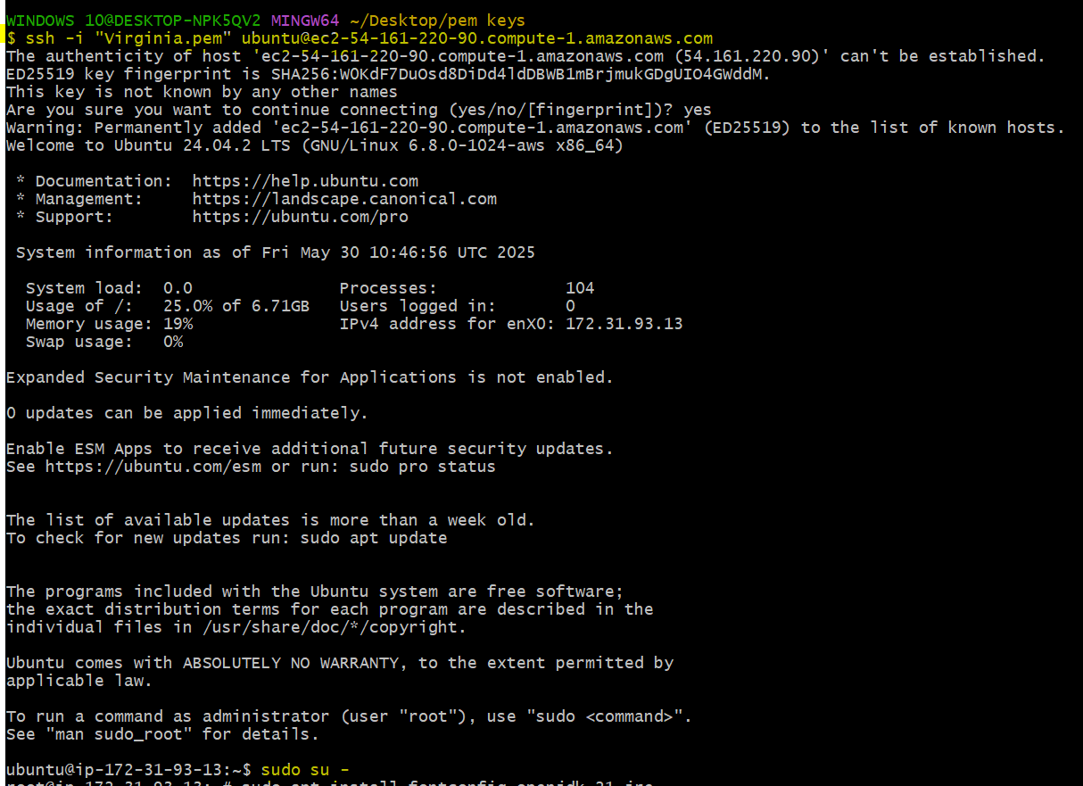
sudo apt-get update
To update the packages.

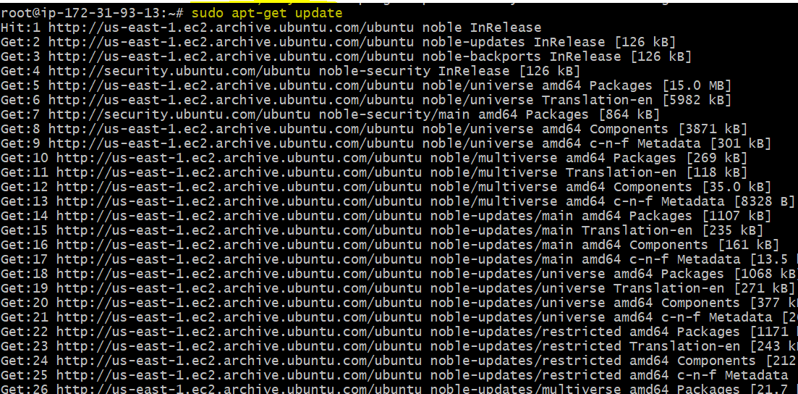

sudo apt install fontconfig openjdk-21-jre
Install JDK 21 required for Jenkins agent (Java-based)

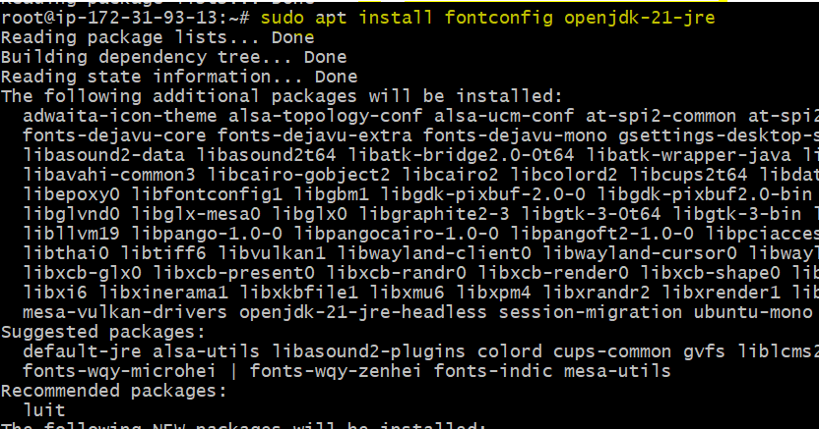

java -version
To verify the version.
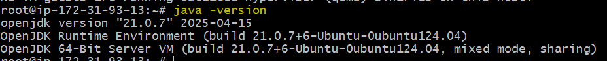

ssh-keygen
Generate SSH key pair for passwordless authentication
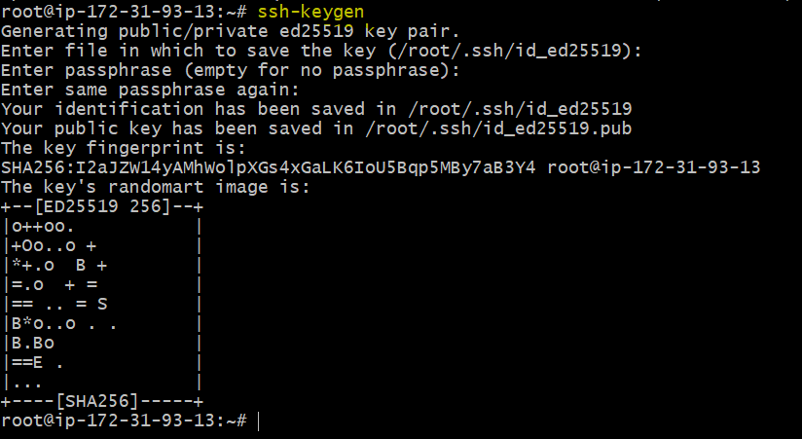

cat id_rsa.pub > authorized_keys
Add public key to authorized list for SSH login
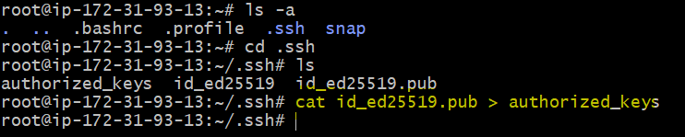

chmod 700 authorized_keys
Set correct permissions to secure the SSH access

Slave – 02:

Log in to the instance and switch to the root user sudo su –

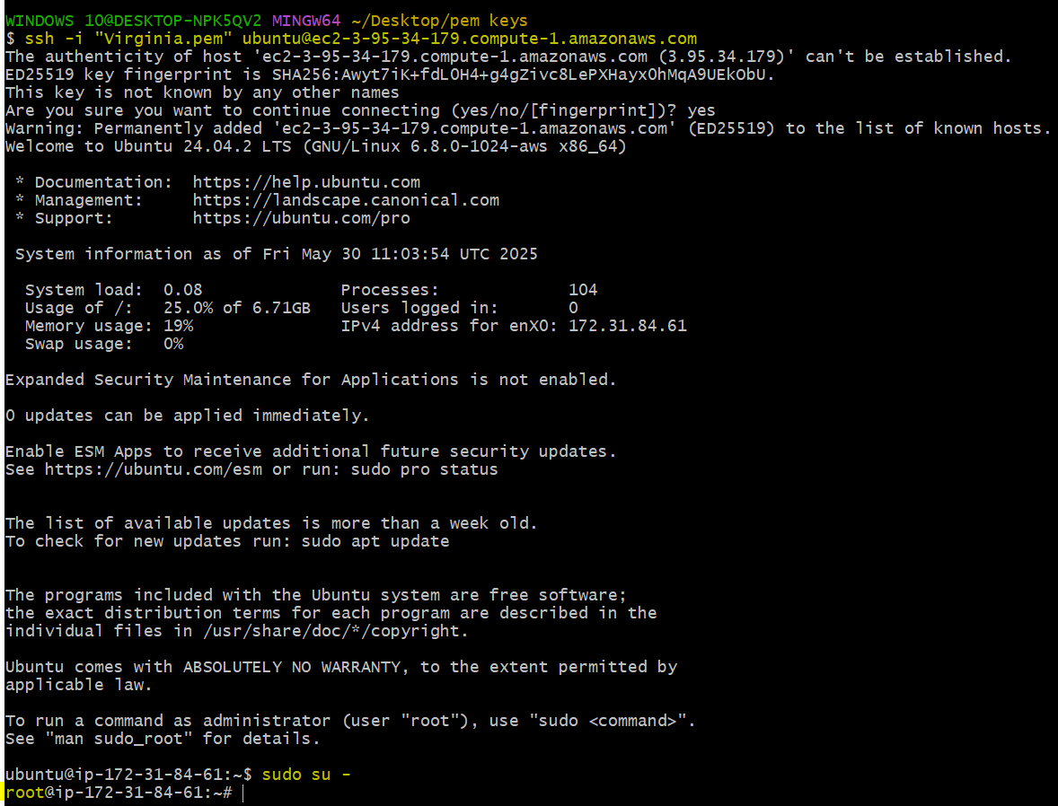

sudo apt-get update
To update the packages.
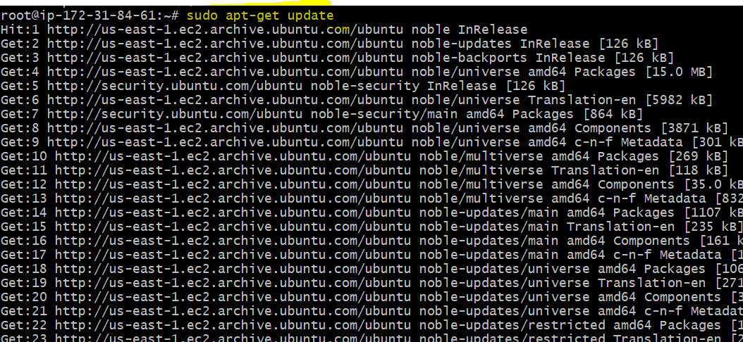

sudo apt install fontconfig openjdk-21-jre
Install JDK 21 required for Jenkins agent (Java-based)
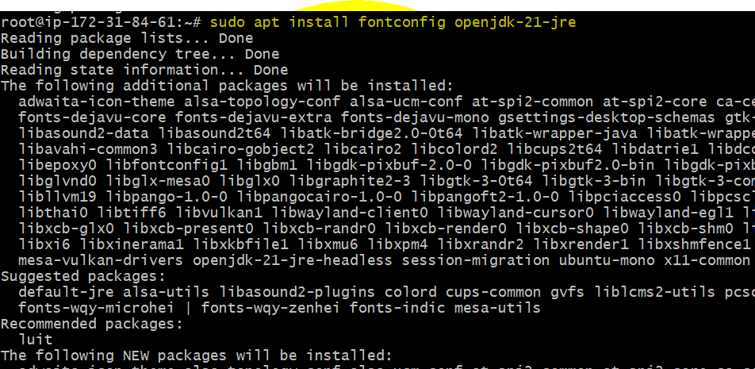

java -version
To verify the version.
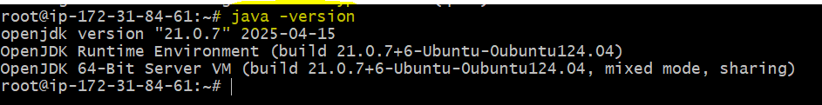

ssh-keygen
Generate SSH key pair for passwordless authentication
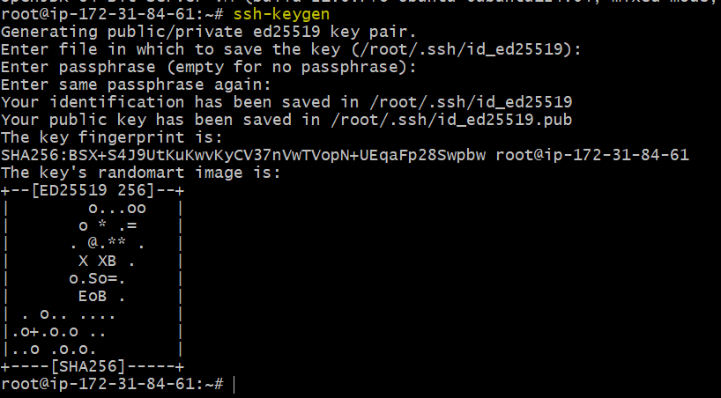

cat id_rsa.pub > authorized_keys
Add public key to authorized list for SSH login
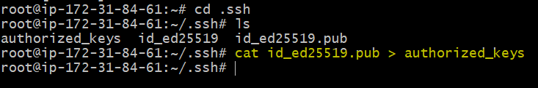

chmod 700 authorized_keys
Set correct permissions to secure the SSH access

Configuration of 2 slave machines is completed.

Steps to be done on master machine:
===========================
Login to master machine
switch to root user.
mkdir -p /var/lib/jenkins/.ssh
cd /var/lib/jenkins/.ssh
ssh-keyscan -H SLAVE-NODE-IP-OR-HOSTNAME >>/var/lib/jenkins/.ssh/known_hosts
# ssh-keyscan -H 172.31.38.42 >>/var/lib/jenkins/.ssh/known_hosts
chown jenkins:jenkins known_hosts
#we need to change the owner as we ran ssh-keyscan command using â€œrootâ€ user.
# default user of Jenkins will be â€œjenkinsâ€
chmod 700 known_hosts
# DOne !!

Configuration changes to be made in Jenkins Master Machine:
Log in to the instance and switch to the root user sudo su –
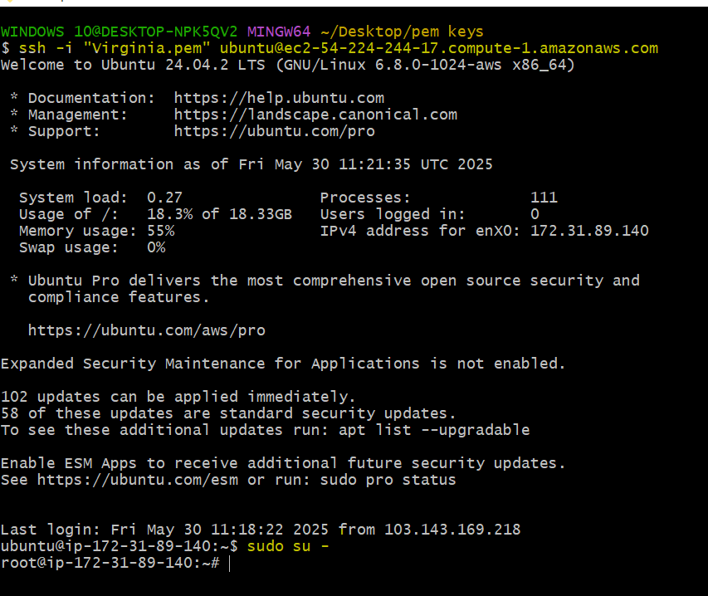
mkdir -p /var/lib/jenkins/.ssh
Create the .ssh directory for Jenkins user if not present

cd /var/lib/jenkins/.ssh
Navigate to the Jenkins user's SSH config directory

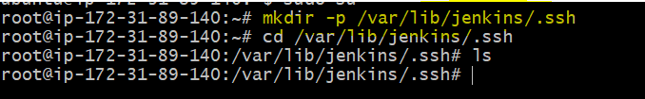

ssh-keyscan -H SLAVE-IP >> known_hosts
Add slave node’s SSH key to known_hosts to prevent prompts

Salve – 01
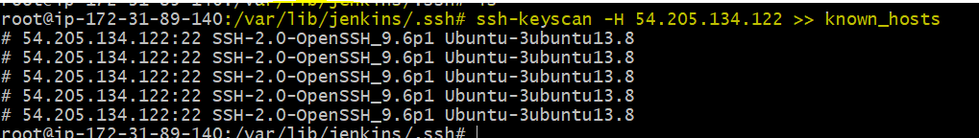
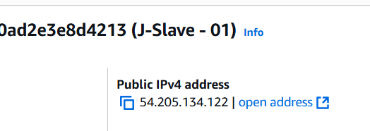

Slave - 02
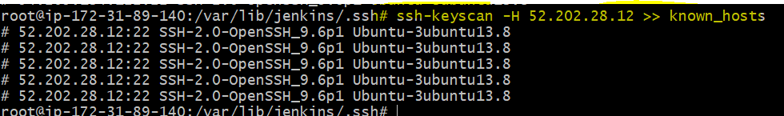
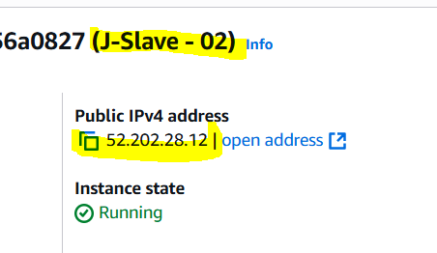
chown jenkins:jenkins known_hosts
Set correct ownership so Jenkins can access the file
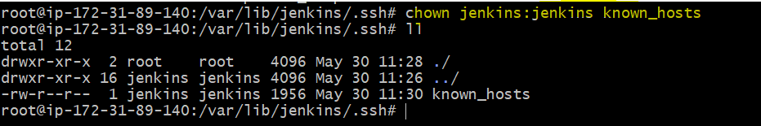

chmod 700 known_hosts
Secure the file so only Jenkins can read/write it
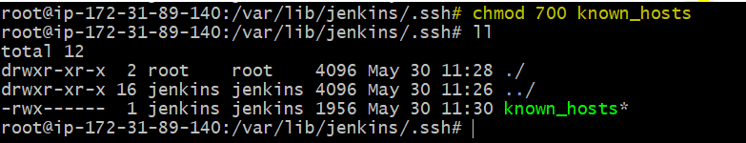

Steps to be done on jenkins GUI:
========================
Go to manage jenkins
open manage node
under launch method select "Launch via SSh"
Host "public ip of slave"
creditals: select user with private key
enter ec2-user as name and paste the pem key.
host key verification startegy to be selected
save..

Slave – 01:

Dashboard → Manage Jenkins → Manage Nodes and Clouds → New Node
→ Enter node name (e.g., slave-1) → Select "Permanent Agent" → OK
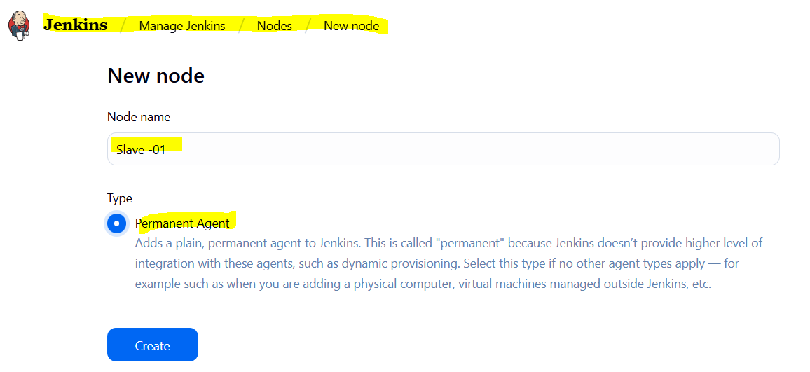

→ Remote root directory: /home/ubuntu
→ Labels: Java
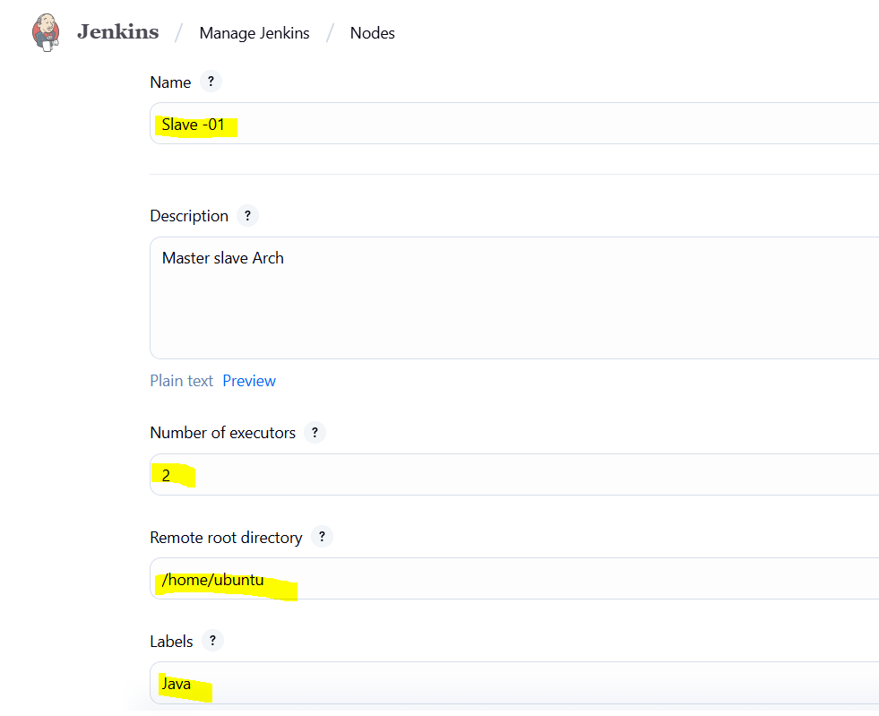

→ Launch method: Launch agents via SSH
→ Host: <Slave-01 Public IP>

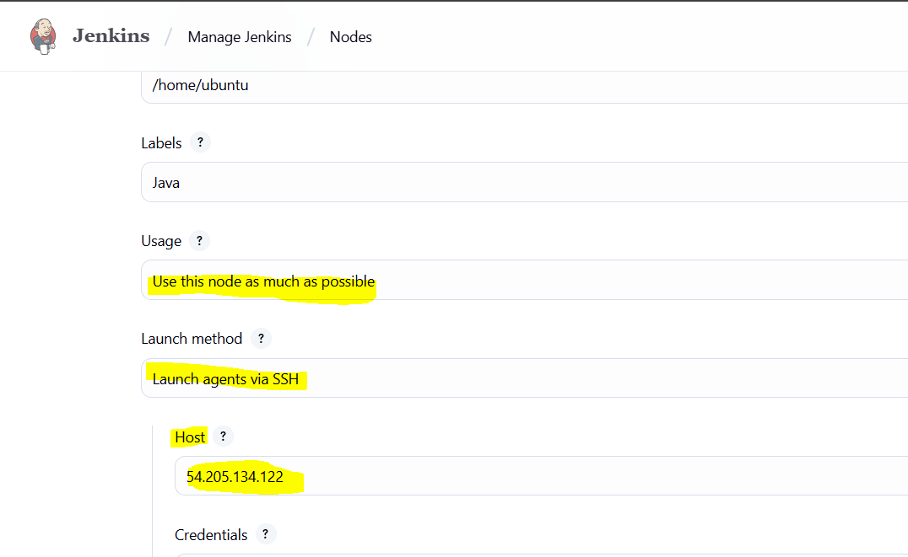

→ Credentials: Add → SSH Username with private key
→ Username: ubuntu
→ Private Key: paste .pem file content
→ Save and select it

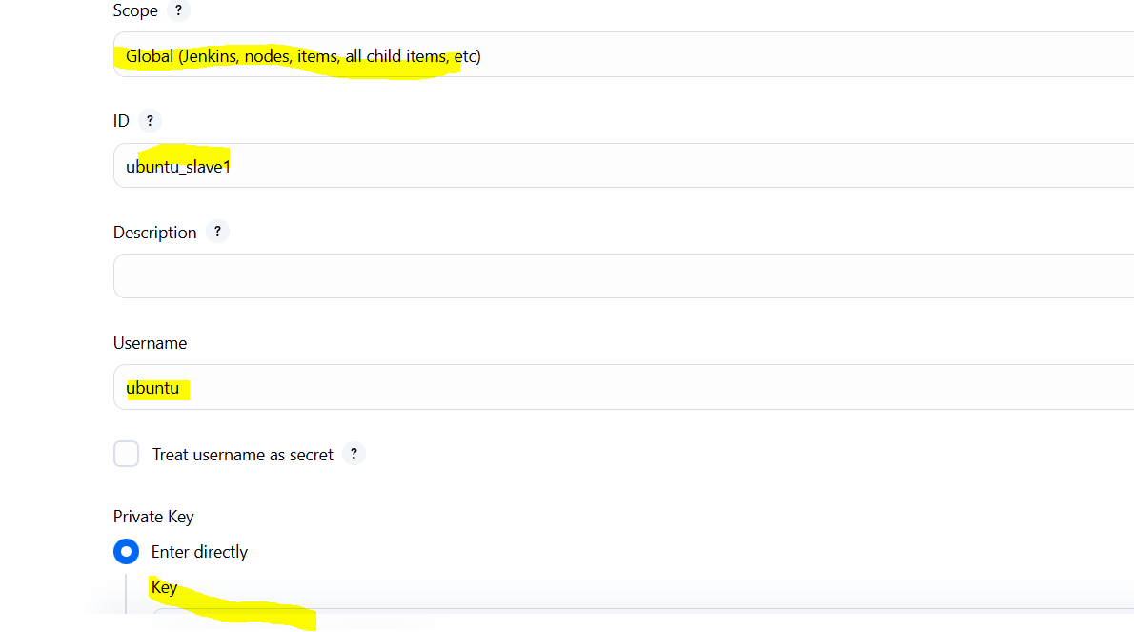
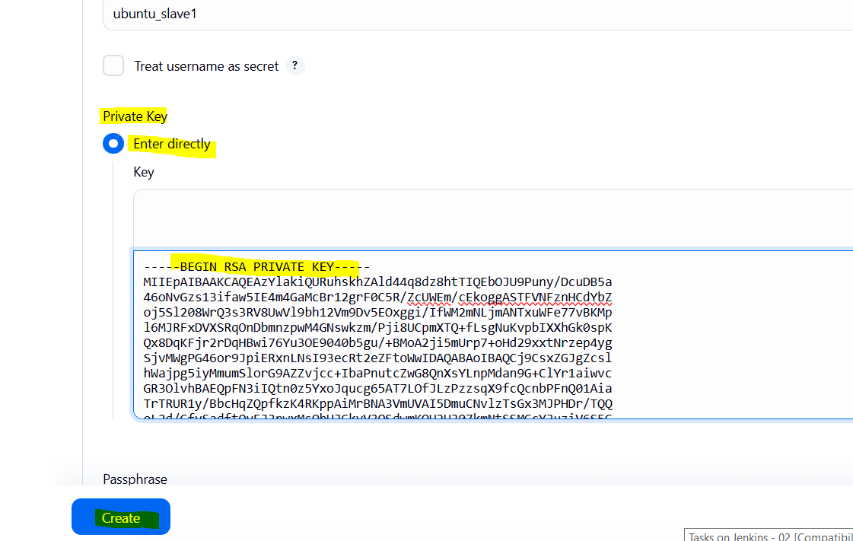

→ Host Key Verification Strategy: Known hosts files Verification Strategy
→ Save
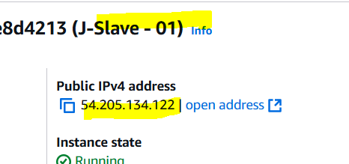
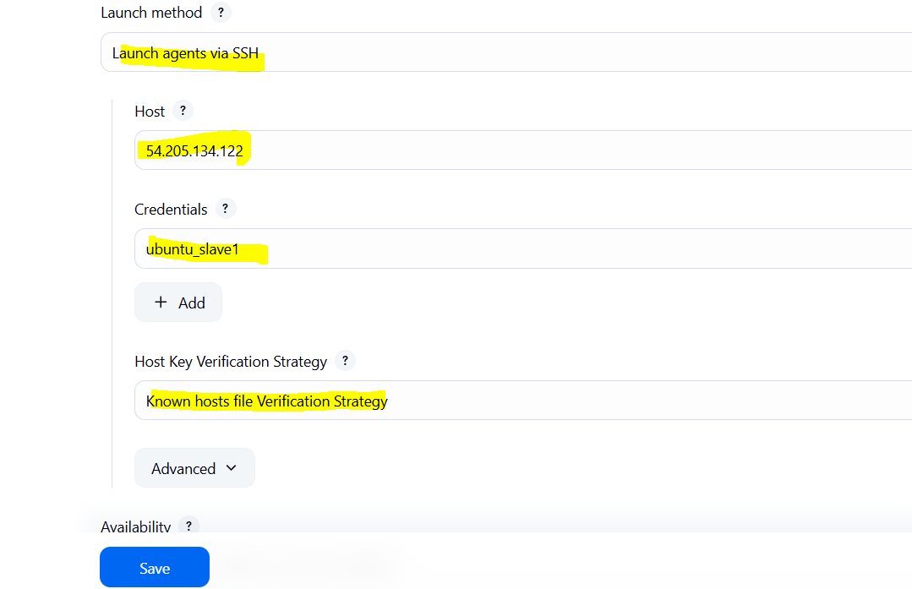

Salve – 02:

Dashboard → Manage Jenkins → Manage Nodes and Clouds → New Node
→ Enter node name (e.g., slave-1) → Select "Permanent Agent" → OK
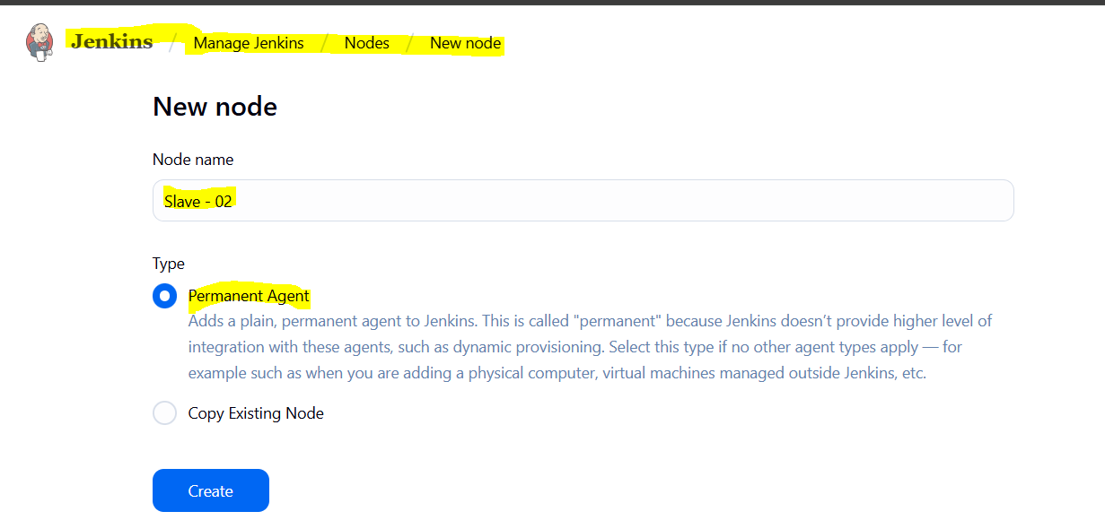

→ Remote root directory: /home/ubuntu
→ Labels: Python
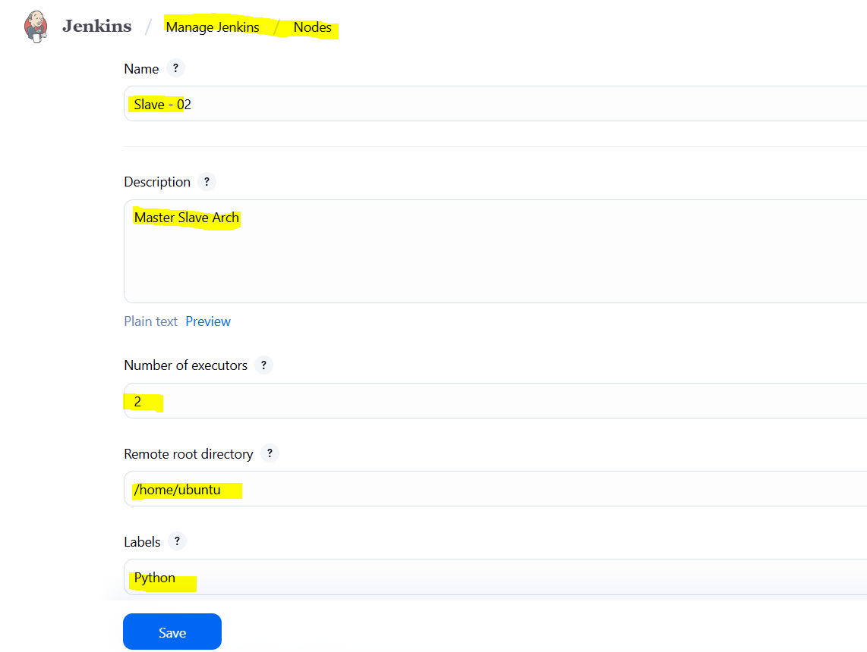

→ Launch method: Launch agents via SSH
→ Host: <Slave-01 Public IP>
→ Using previously Created Credentials.
→ Host Key Verification Strategy: Known hosts files Verification Strategy
→ Save
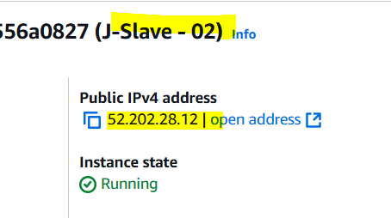
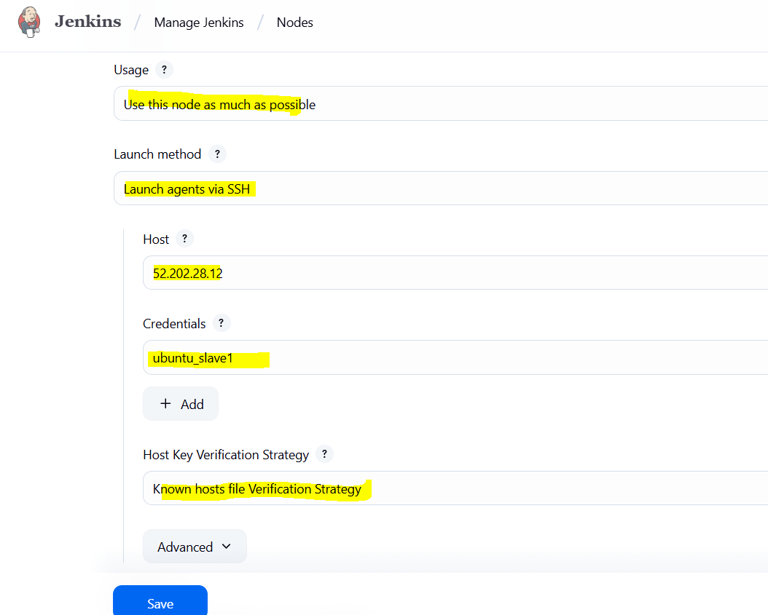

Both Slaves are configured into the jenkins.
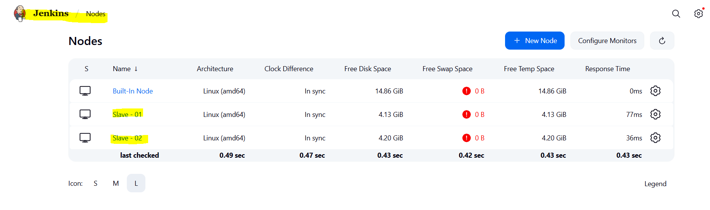

Testing slave-01:
Executing Sample - 01 job after adding label Java to it and checking slave-01 Root directory whether workspace directory created or not at /home/ubuntu.
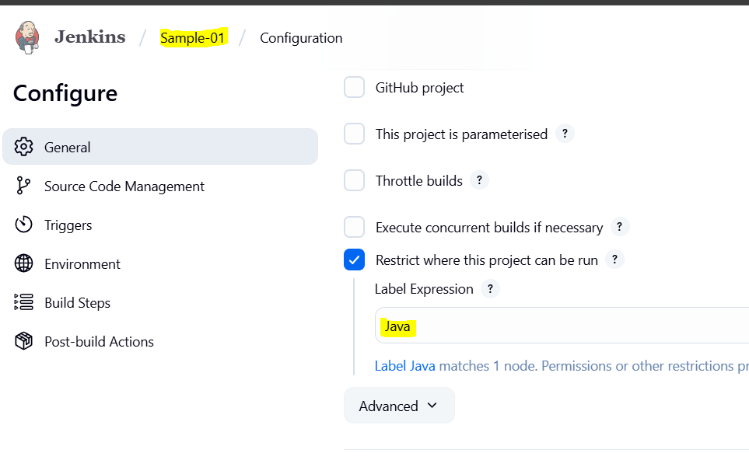

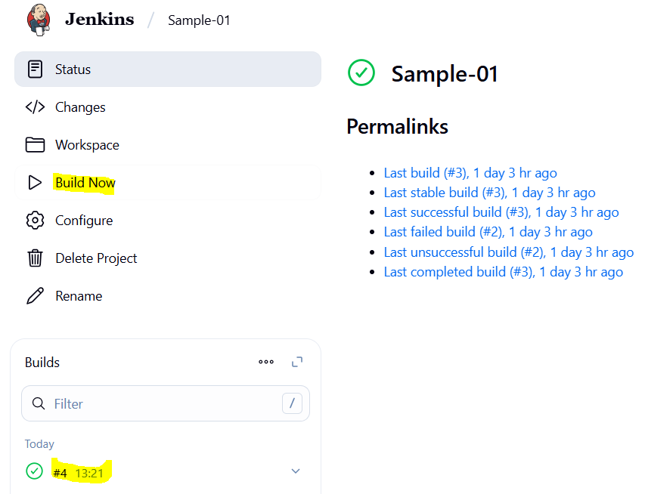
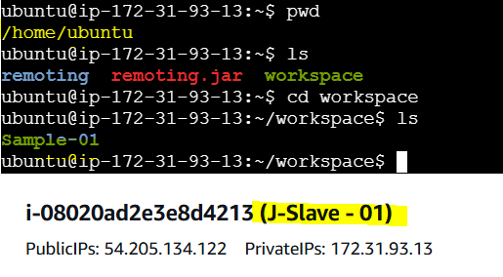

Testing slave-02:
Executing Sample - 02 job after adding label Python to it and checking slave-02 Root directory whether workspace directory created or not at /home/ubuntu.
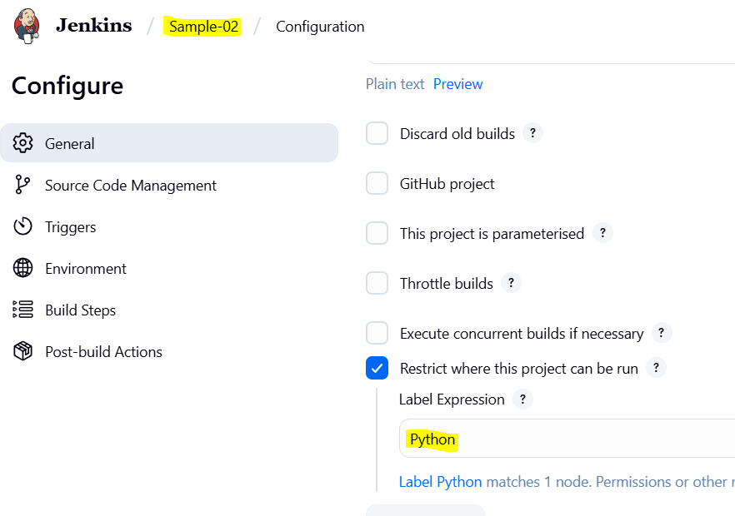
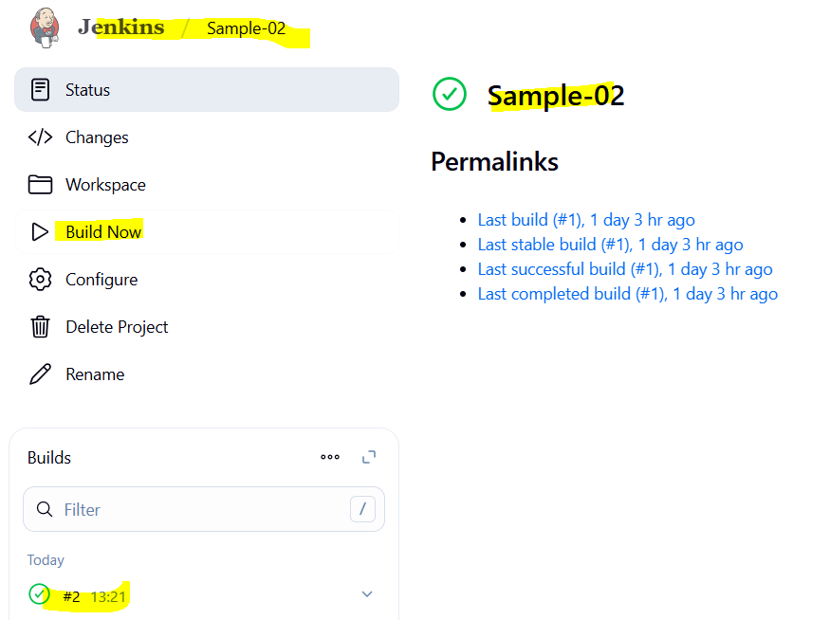
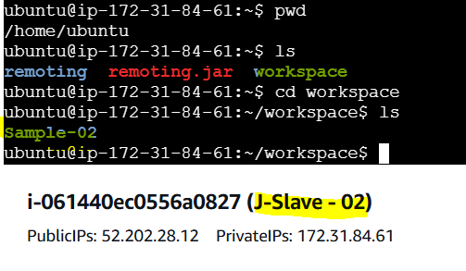

2) Configure webhooks to jenkins job.

First, we need to create webhooks in repository.
Repo → Settings → Webhooks → Add webhook
Payload URL → http://<jenkins-url>/github-webhook/
Content type → application/json
Events → Just the push event → Add webhook

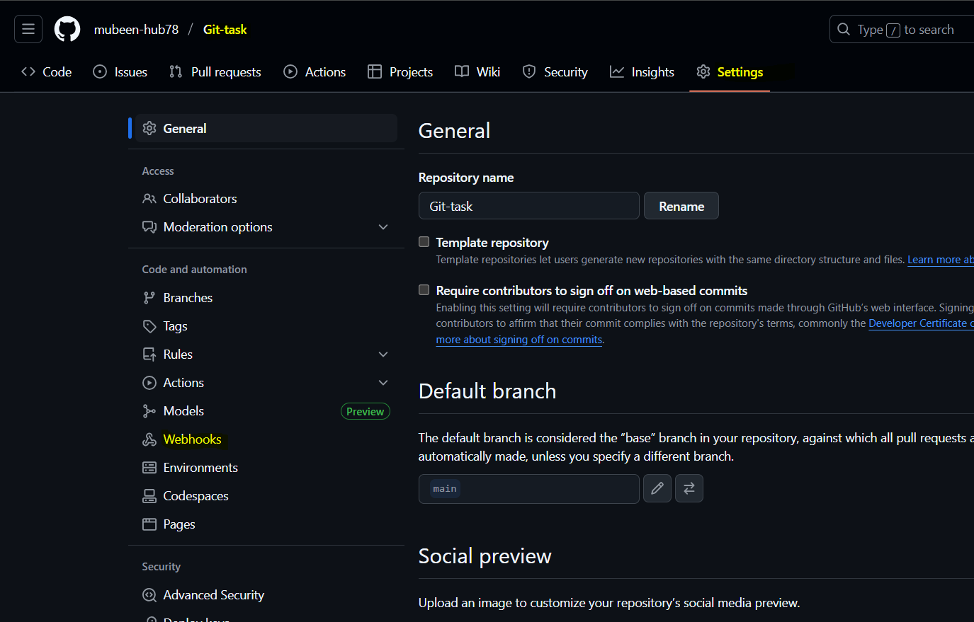
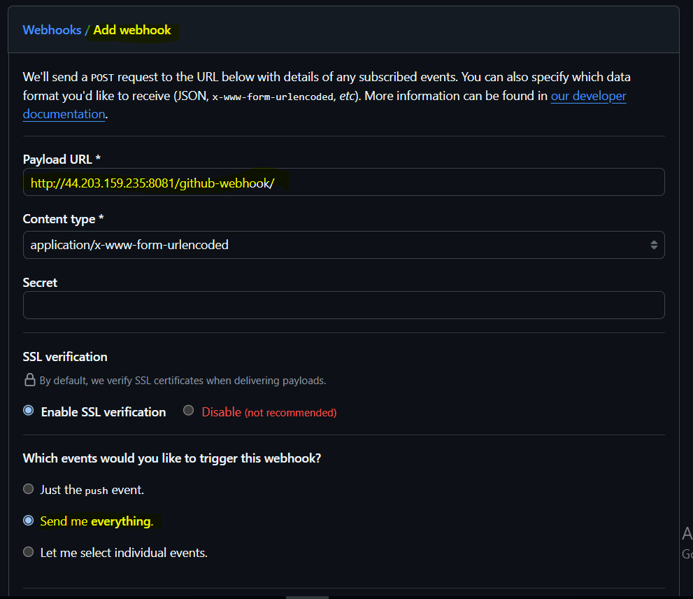
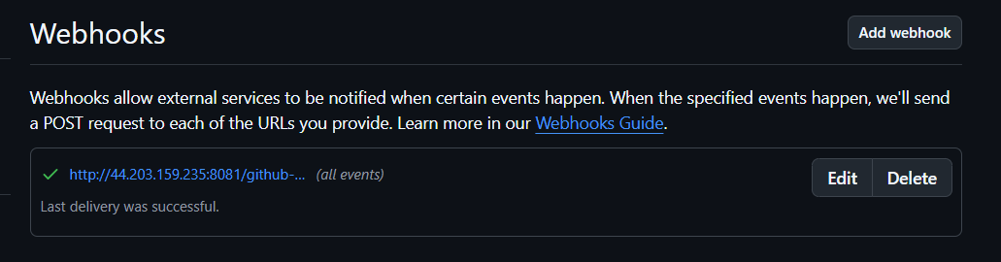

Jenkins: Now we are enabling GitHub hook trigger for GITScm polling in Triggers. So if any changes are made in Repository job will be automatically executed.
Dashboard → Job → Configure → Build Triggers → GitHub hook trigger for GITScm polling → Save
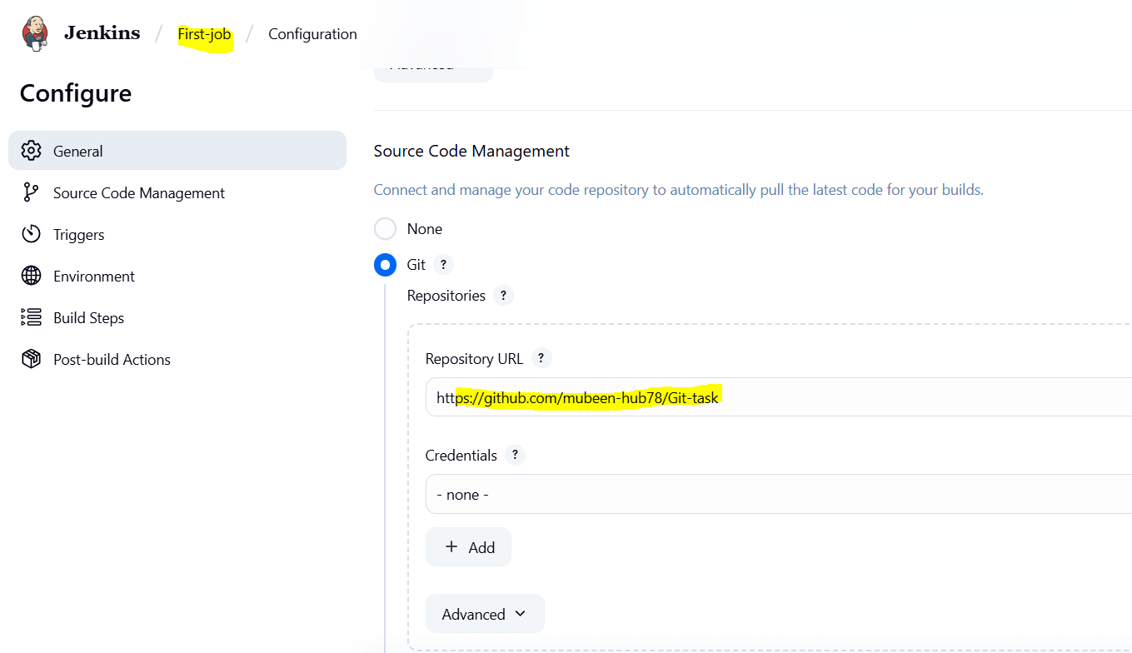
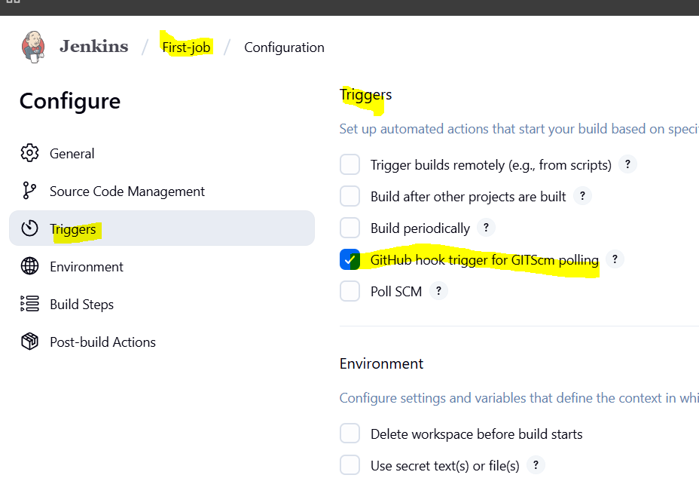

Now we are editing source code/committing changes in Repository.

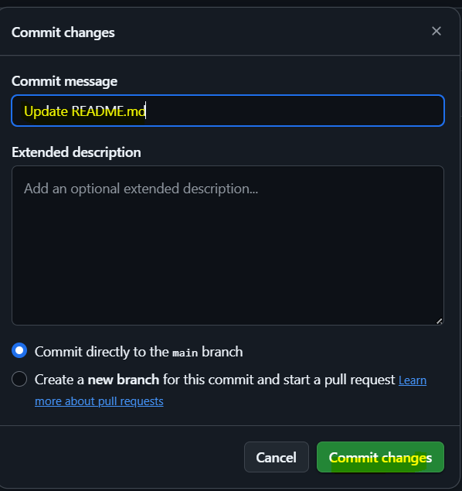

Job is triggered after changes and job is executed automatically.
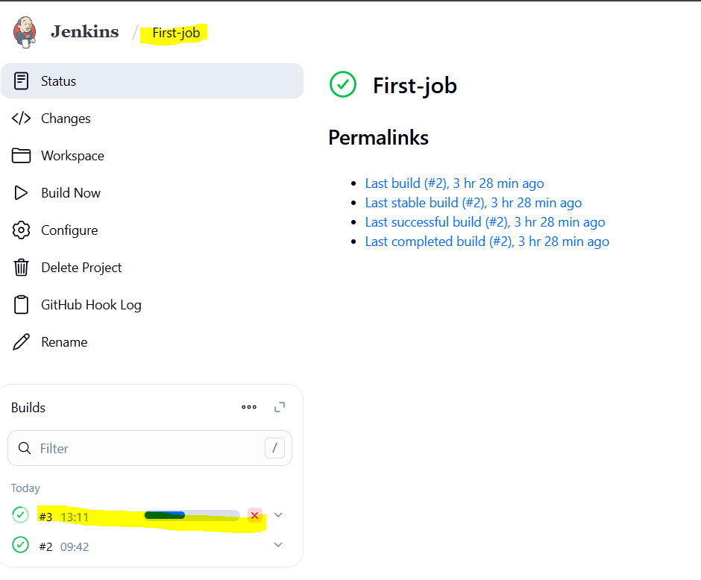
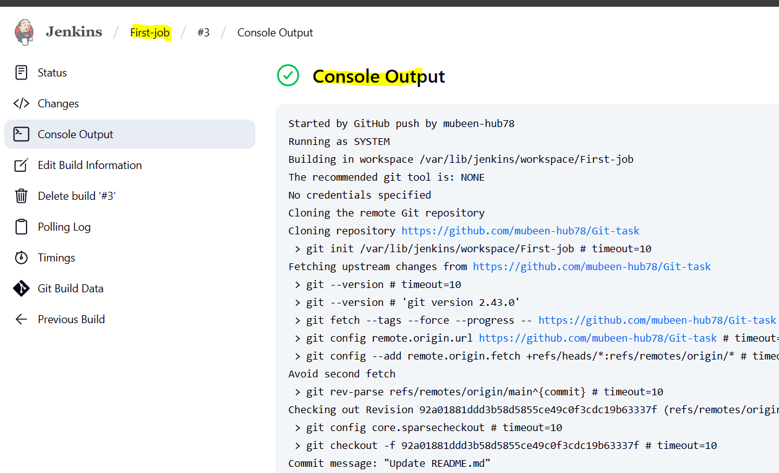

3) Configure poll scm and build periodical options in jenkins job.

Poll SCM:

We are enabling Poll SCM, with scheduling ***** 5 starts (similar to cronjob) that means job will be executed after every minute when there are changes made in Repository. Using the same job and same repo to test Poll SCM.

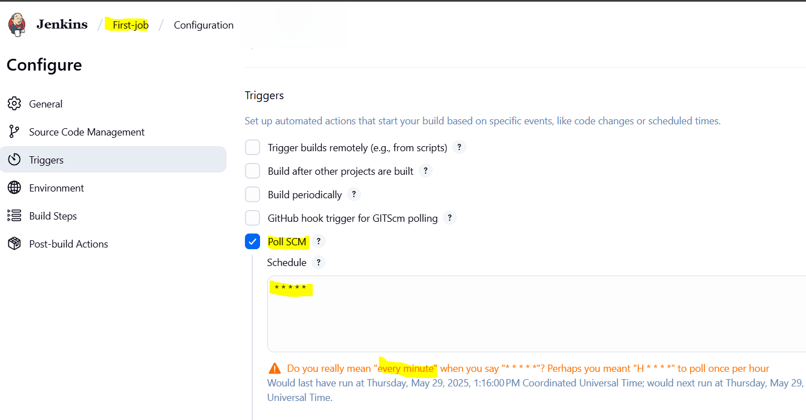

Need to make changes in repo and need to wait for 1 min so the job can be executed automatically after triggering.

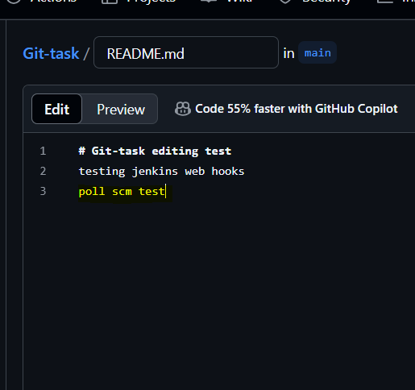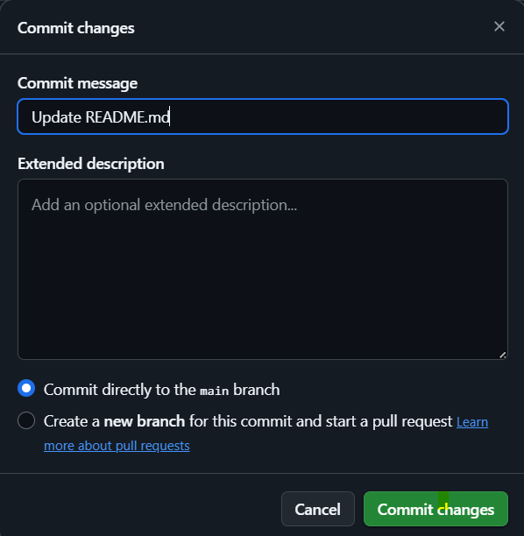

We can see that job is executed successfully.
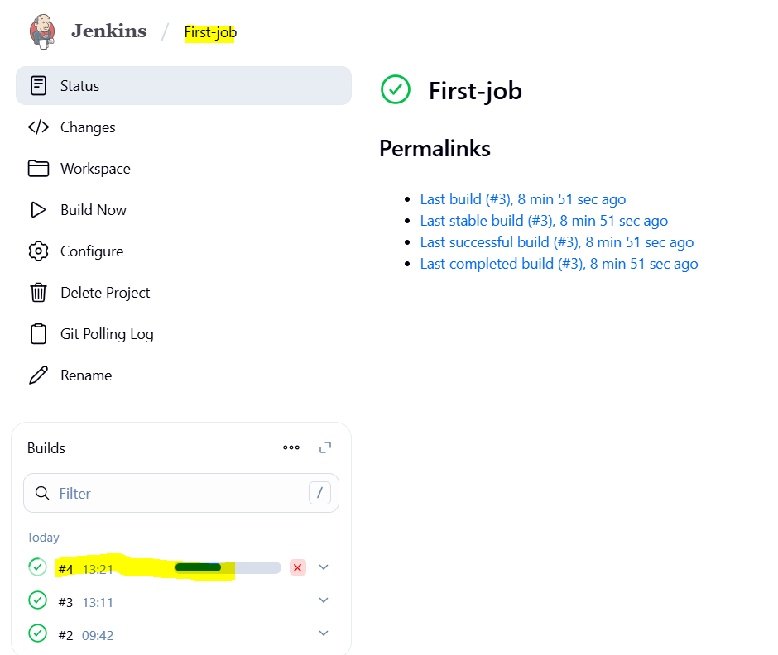
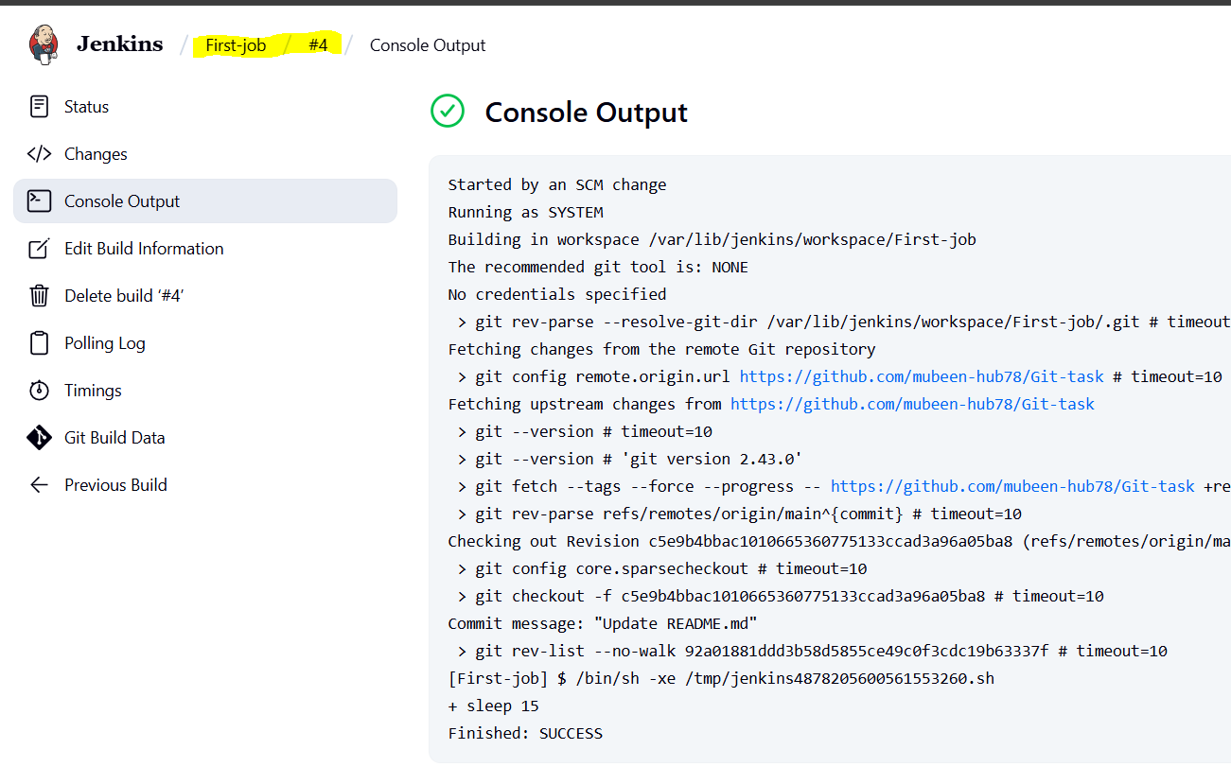

Build periodically:

This triggering option is used for Scheduling directly it doesn’t have any dependencies like we have in Poll SCM (Only executes when there is a change in Repo). It is also similar to cronjob uses ***** 5 stars. Job will be executed every minute without any dependency.

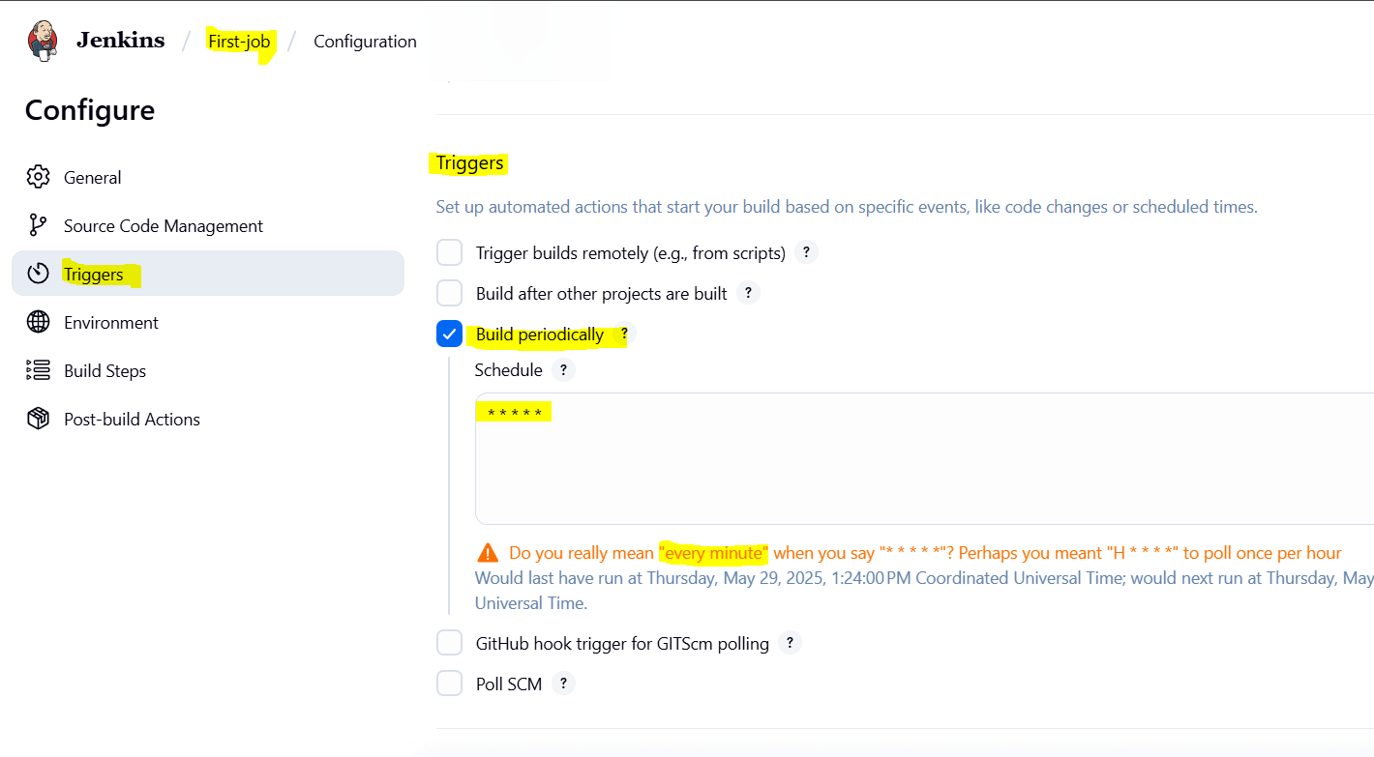

Here we can see that job is executed automatically as scheduled after every 1 min.
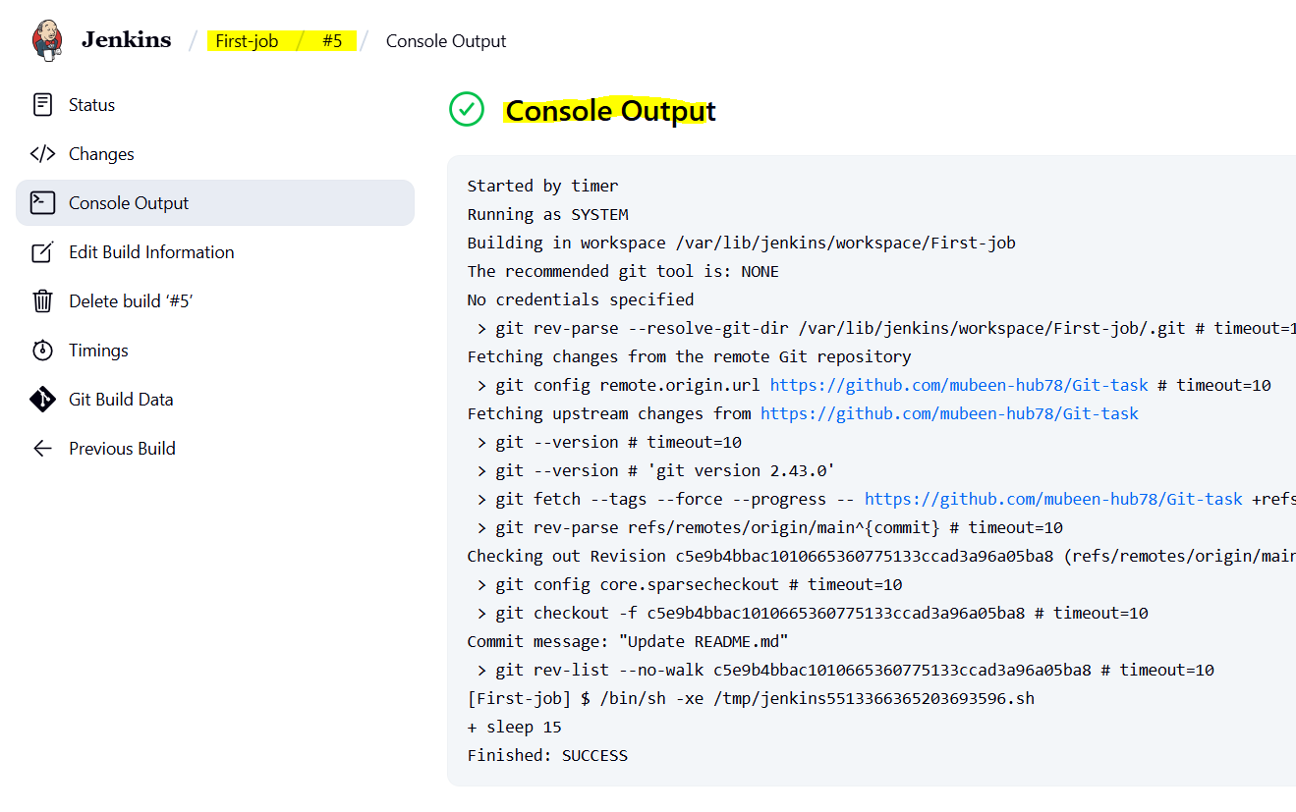
Job is executed again after every min.
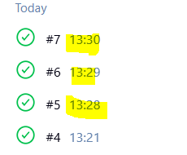

4) Take backup of jenkins server by using bash script.

Script for backup:
#!/bin/bash
# Purpose: Jenkins backup script
# Owner: Mubeen

# Paths
JENKINS="/var/lib/jenkins"
BACKUP="/var/backups/jenkins"

# For timestamp
DATE=$(date +%F-%H-%M)

BACKUP_PATH="$BACKUP/jenkins-backup-$DATE.tar.gz"

# Create backup
tar -czf "$BACKUP_PATH" -C "$JENKINS" .

echo "Jenkins backup completed: $BACKUP_PATH"
It can be scheduled with cronjob as required.
Now paste the script and execute to create a backup at the path /var/backups/jenkins/:
mkdir -p /opt/scripts
Create /opt/scripts directory (including parents) to store backup scripts

vi jenkins_backup.bash
Open vi editor to create/edit the backup script file named jenkins_backup.bash

chmod +x jenkins_backup.bash
Make the script executable so it can be run as a program

./jenkins_backup.bash
Run the backup script from the current directory
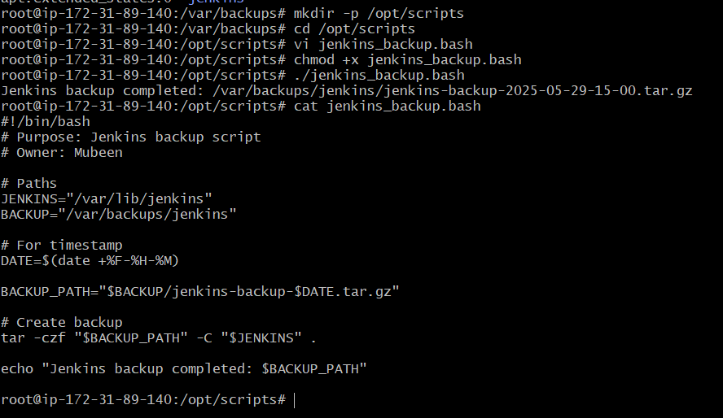
We can check the backup at path /var/backups/jenkins/
Successfully backup completed using the script.

5) Take backup of jenkins using rethin backup plugin.

Jenkins → ThinBackup Setup

1. Jenkins → Manage Jenkins

2. → Manage Plugins → Available

3. Search: ThinBackup → Install

4. Jenkins → Manage Jenkins → ThinBackup

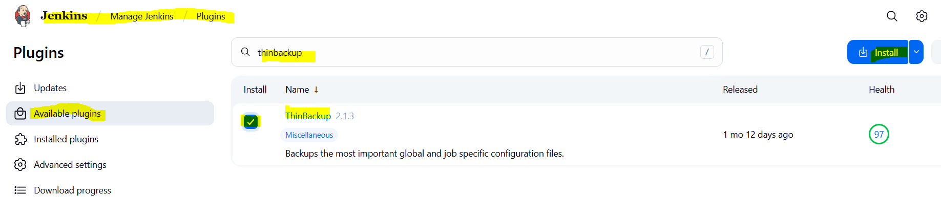
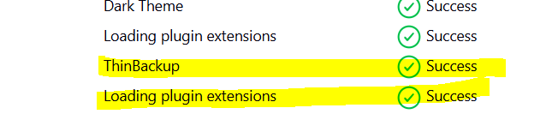

Configure ThinBackup

Jenkins → Manage Jenkins → System → Thinbackup
- Backup directory → /var/backups/jenkins/ (or your desired path)
- Backup schedule → set (e.g., daily) 00:00 Midnight daily. (Anyhow for now executing 5* for test)
Click Save
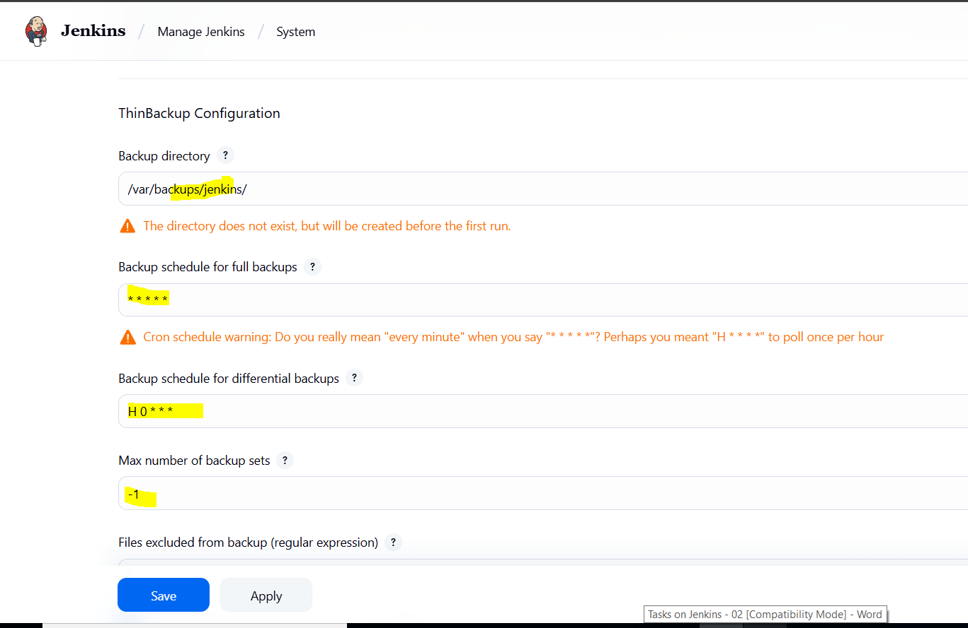
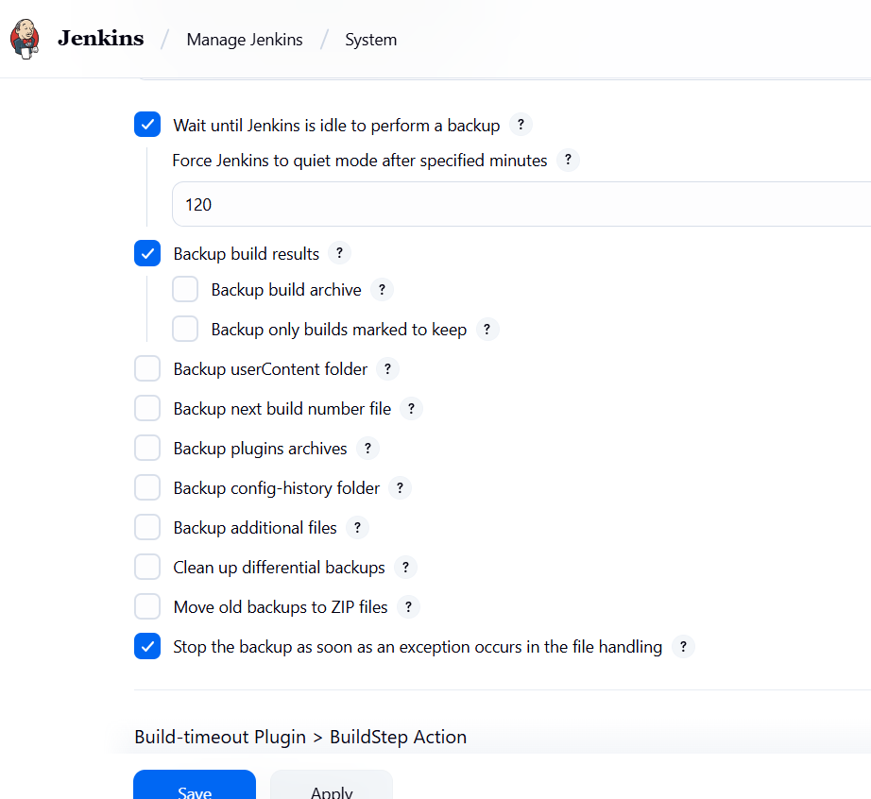

As per schedule we can check the Backup is created or not for every minute, Usually backup will be done after 3-4 days. For testing purpose it scheduled for every minute.
Need to check this path /var/backups/jenkins/.
mkdir -p /var/backups/jenkins/
Create the directory /var/backups/jenkins/ including parent directories if they don't exist
chown -R jenkins:jenkins /var/backups/jenkins/
Change ownership of the directory and all its contents to user 'jenkins' and group 'jenkins'
so Jenkins has permission to write backups here
ls /var/backups/jenkins/
List the contents of the backup directory to verify backups are saved or the directory exists
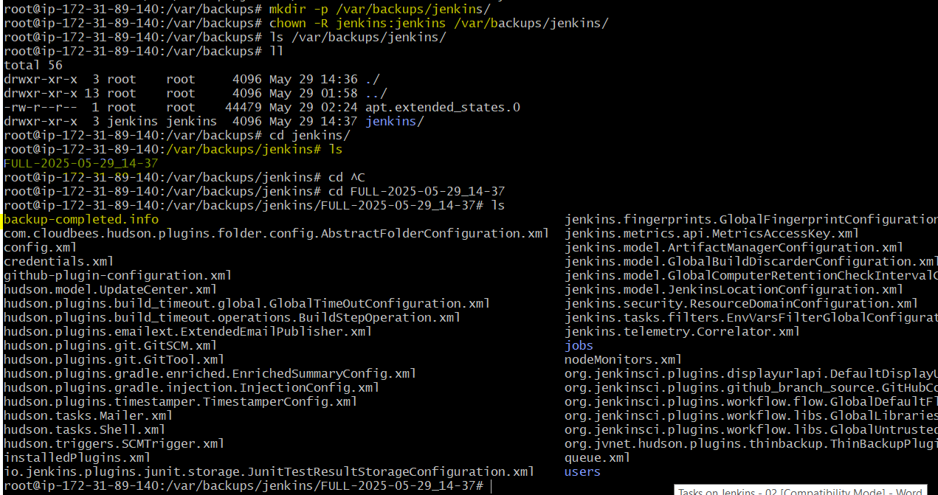

6) Setup a new jenkins server and dump the backup taken in task4.

Launching instance OS as ubuntu and storage with 20GB as similar to the jenkins Instance previously launched.
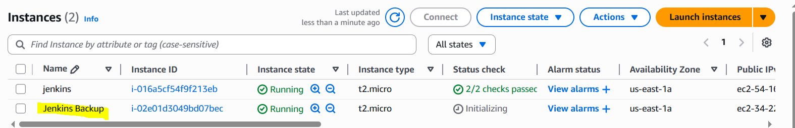

Connect to the instance and install Java and Jenkins.

sudo apt update
Updates the local package list from the repositories
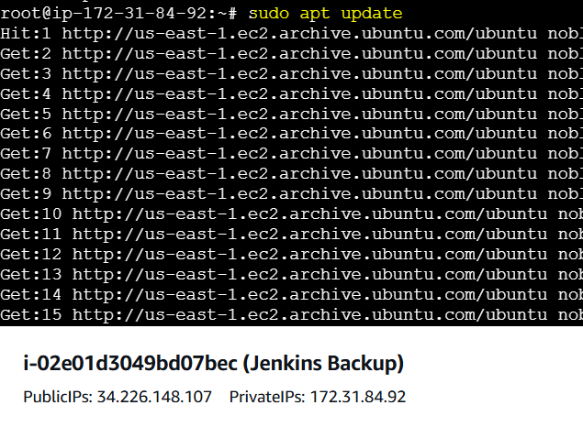

sudo apt install fontconfig openjdk-21-jre
Installs the Java Runtime Environment (OpenJDK 21) and fontconfig (a required dependency for Java UI apps)

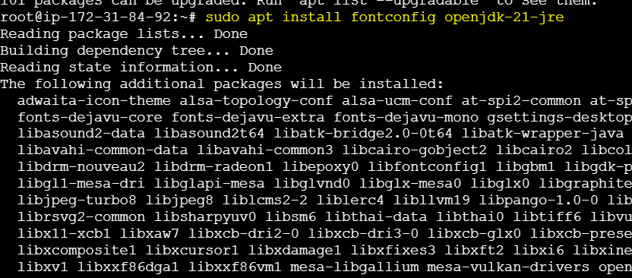

java -version
Displays the installed Java version to confirm installation

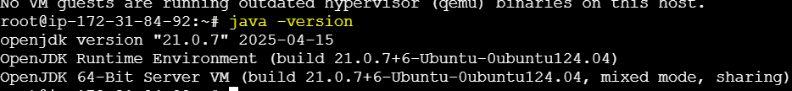

To install Jenkins:

sudo wget -O /etc/apt/keyrings/jenkins-keyring.asc \
https://pkg.jenkins.io/debian/jenkins.io-2023.key
Downloads the Jenkins GPG key and saves it to the keyrings directory for secure package verification

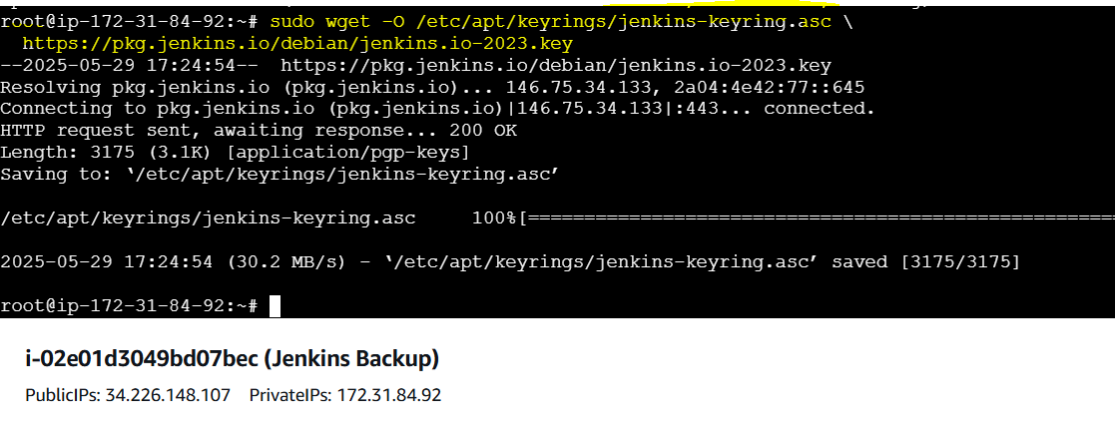

echo "deb [signed-by=/etc/apt/keyrings/jenkins-keyring.asc] \
https://pkg.jenkins.io/debian binary/" | sudo tee \
/etc/apt/sources.list.d/jenkins.list > /dev/null
Adds the official Jenkins APT repository to your system so Jenkins can be installed via apt

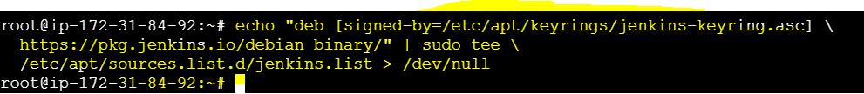

sudo apt-get update
Updates the local APT package index to recognize Jenkins packages from the newly added repository

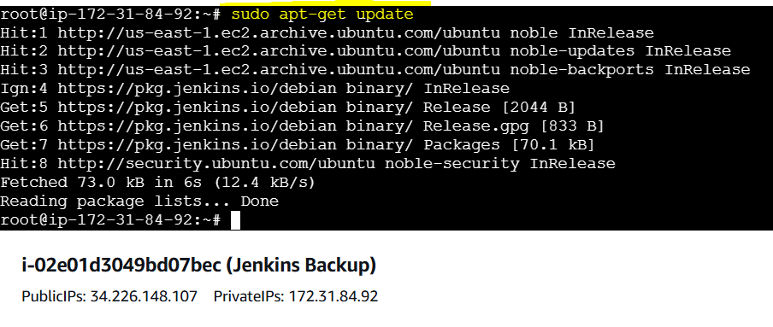

sudo apt-get install jenkins
Installs Jenkins using the package information from the official Jenkins repository

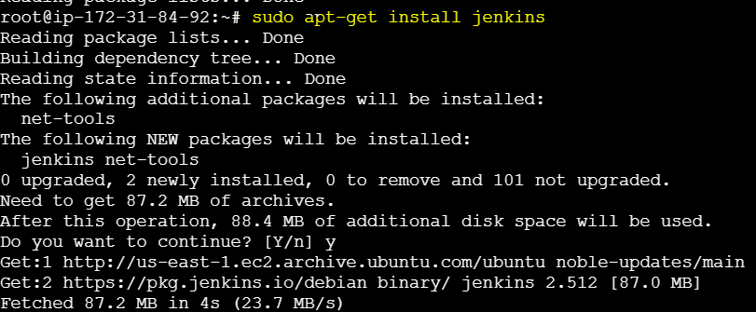

sudo systemctl status jenkins
To check service is active or not.
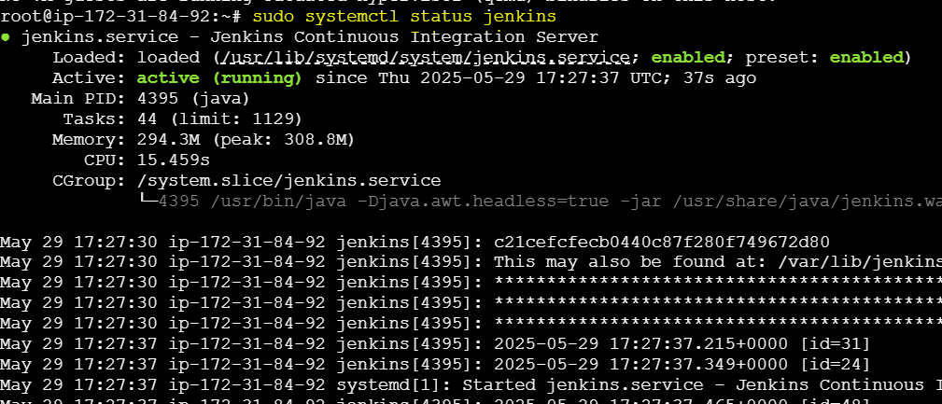

Now we need to add pem.key/password less authentication to use SCP command for copying Backup to another server.

Copied pem.key from local to jenkins server, at the path where backup is available.
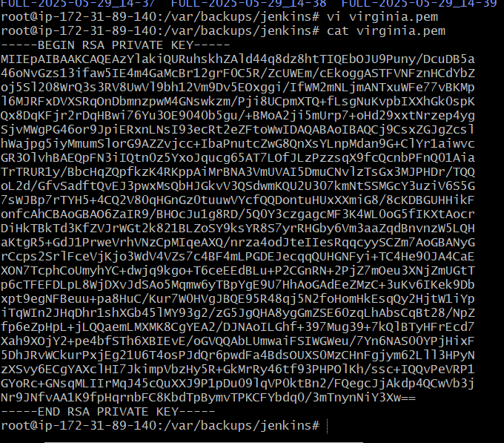
chmod 400 virginia.pem
Change permissions

scp -i virginia.pem jenkins-backup-2025-05-29-15-00.tar.gz ubuntu@ 34.226.148.107:/tmp/
This command is executed in jenkins server and used public ip is of jenkins backup server. Command used to copy backup from jenkins server to jenkins backup server.

Backup is copied successfully to the jenkins backup server.

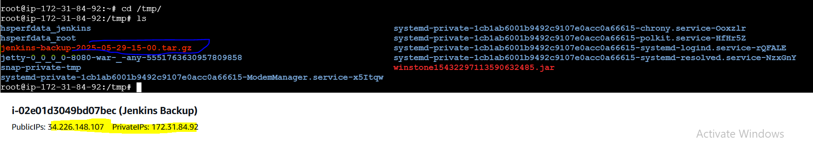

Now we have to extract the backup tar in /var/lib/ path.

sudo tar -xzf jenkins-backup-2025-05-29-15-00.tar.gz -C /var/lib/jenkins/
Using this command we can extract the backup at target path.

sudo systemctl restart jenkins
to apply configuration changes.

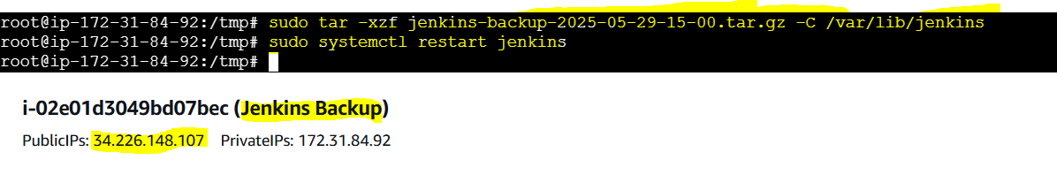

Setup of new jenkins server is successfully completed by Dumping the Backup.

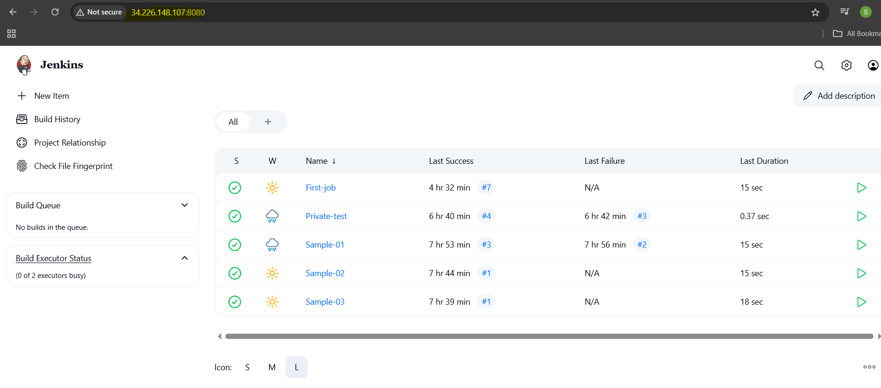

The-End

